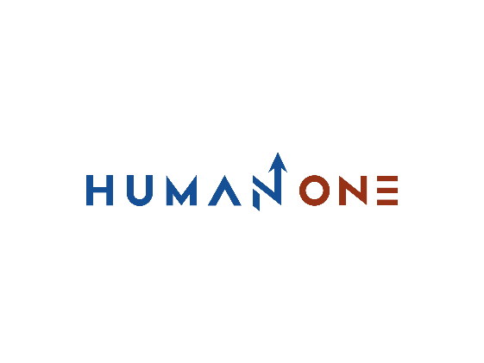

Services

Big Data & analytics

Platform Development

Expertise

**EN**

**FR**

Get in touch

Company

Cloud

Devops

Machine learning & IA

Internet of Things Development Services

**Internet of Things Development Services**



At HumanOne, we partner with IoT providers and enterprise adopters in the automotive, transportation, real estate, retail, and other industries, enabling them to unlock the business value of connected devices. Our cross-functional experts help organizations harness the right IoT technology stack to build data-rich software solutions for connected vehicles, smart facilities, personal devices, industrial purposes, and beyond.

Let’s Talk

**Industrial IoT**

**IoT segments we work with**

**HumanOne software development services for Internet of Things industrial automation**

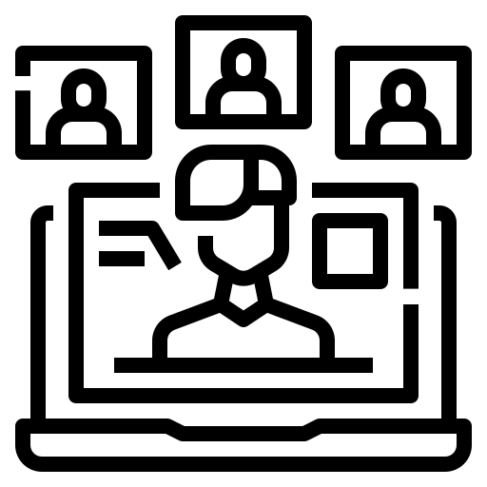

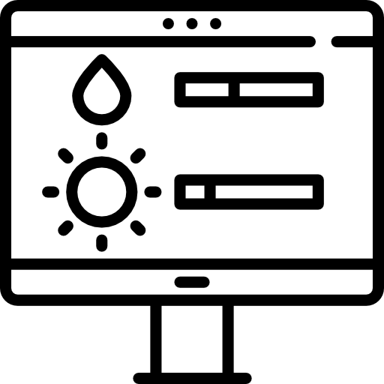



**Predictive maintenance**

Forecast equipment failures and schedule its maintenance before actual failures occur

**Condition monitoring**

Identify hidden defects in your machinery in order to prevent unexpected breakdowns

**Remote management**

Get real-time data from your assets installed across locations to achieve their maximum uptime



**Inventory management**

Optimize your MRO inventory to ensure that all critical spares are always in stock



**Smart logistics**

Gain visibility into your supply chain processes and improve the warehouse inventory control

**Safety monitoring**

Transform your workers’ experience by establishing a safe industrial environment

**Consumer IoT**

**HumanOne consumer IoT software development services cover the following consumer segments**

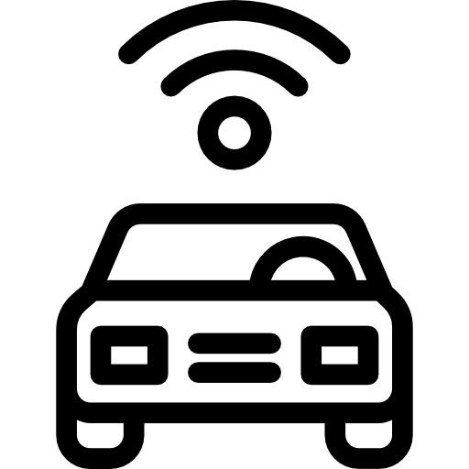





**Connected cars**

We develop custom IoT platforms and software components for vehicles, helping automotive OEMs improve the in-car experience, enable seamless “over the air” upgrades, and deliver vehicle features that meet the marketplace demands

**Wearable devices**

We create software for different types of wearable gadgets, including Bluetooth devices, smart watches and activity trackers among others, as well as build corresponding mobile and web apps to enable convenient user-to-device interactions

**Smart homes**

We provide comprehensive IoT-based home automation solutions to connect all the smart home components – such as devices, security systems, virtual assistants and beyond – and make them accessible through one central control point

**Internet of Things for smart cities solutions we implement:**

**Smart Cities solutions**







**Urban mobility**

Integrated multimodal routing solutions, as well as digital parking and smart traffic systems

**Street lighting**

Intelligent systems for lighting scenarios management, automatic ON/OFF and dimming control

**Remote management**

Meter data management solutions for precise meter readings and accurate resource distribution

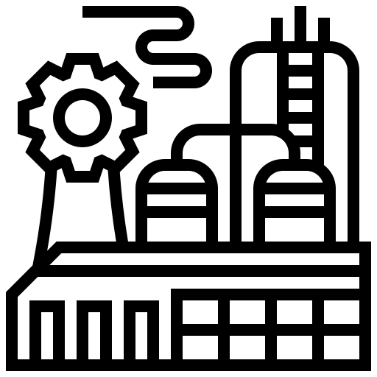





**Public Safety**

Monitoring solutions that detect motion to track perpetrators and identify possible crime scenes

**Facilities management**

Cohesive software solutions for more sustainable spaces and engaging workplace experiences

**Waste Management**

Smart solutions for preventing garbage bins overflows and optimizing waste collection process

**Our custom IoT software development services**

**IoT Consulting**

Work with our experts to shape your digital strategy and effectively capitalize on IoT by turning data insights into new business models and revenue streams



IoT projects in the HumanOne portfolio range from embedded and connectivity solutions to comprehensive platforms backed by AI-based analytics. We provide custom IoT development services that enable businesses to manage their operational efficiency, set up processes, and provide visibility over departments by integrating IoT apps, mobile devices, cloud services, and physical objects into a hyper-connected ecosystem built around end users.

**IoT**

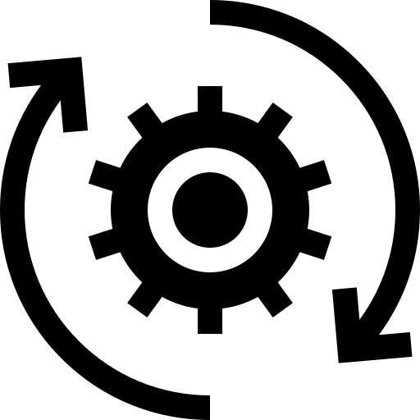

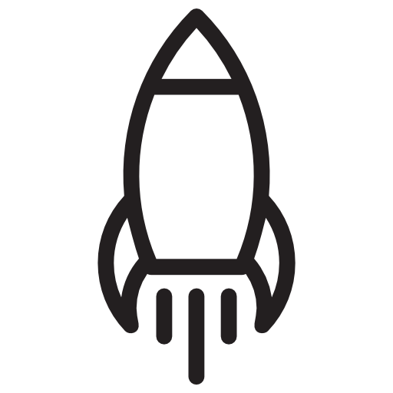

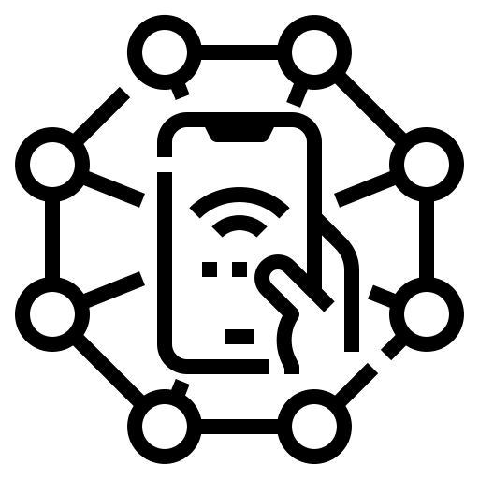

**IoT software enhancement**

Leverage our engineering expertise to tune your current IoT platform or build custom software solutions on top of it to meet new business objectives

**Full-cycle IoT development**

Streamline your path from initial idea to ready solution with our end-to-end software development services, covering all stages of your digital transformation

**IoT acceleration**

Speed up your IoT solution development by using our IoT accelerator as a kick-off point to manage device connectivity based on predefined scenarios

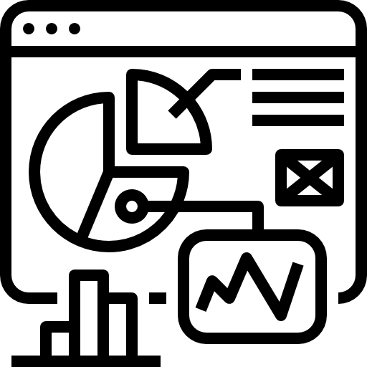

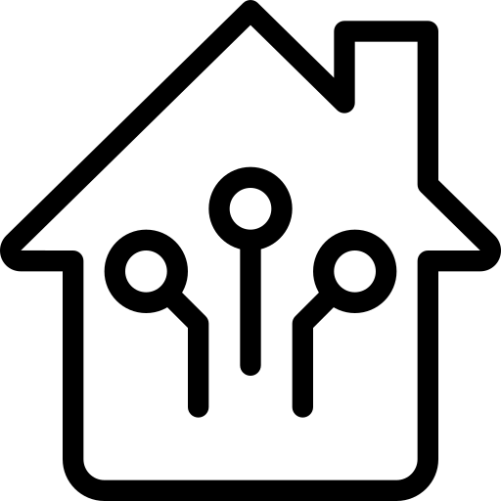

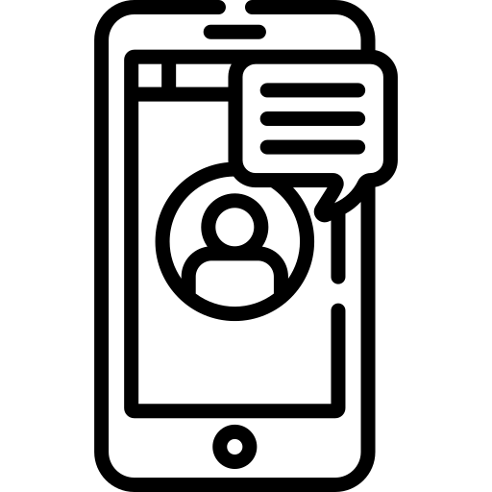

**IoT integrations**

Maximize the value of your IoT initiative by ensuring your software platform is compatible with existing infrastructure and legacy equipment

**User app development**

Explore the data your devices provide and manage them on the go with native mobile and web applications powered by anintelligent UX

**IoT analytics**

Unlock the full potential of real-time data by using our extensive AI skillset to generate actionable insights and credible predictions

Ready to jumpstart your IoT project?

Get in touch

**IoT data flow stages we cover**

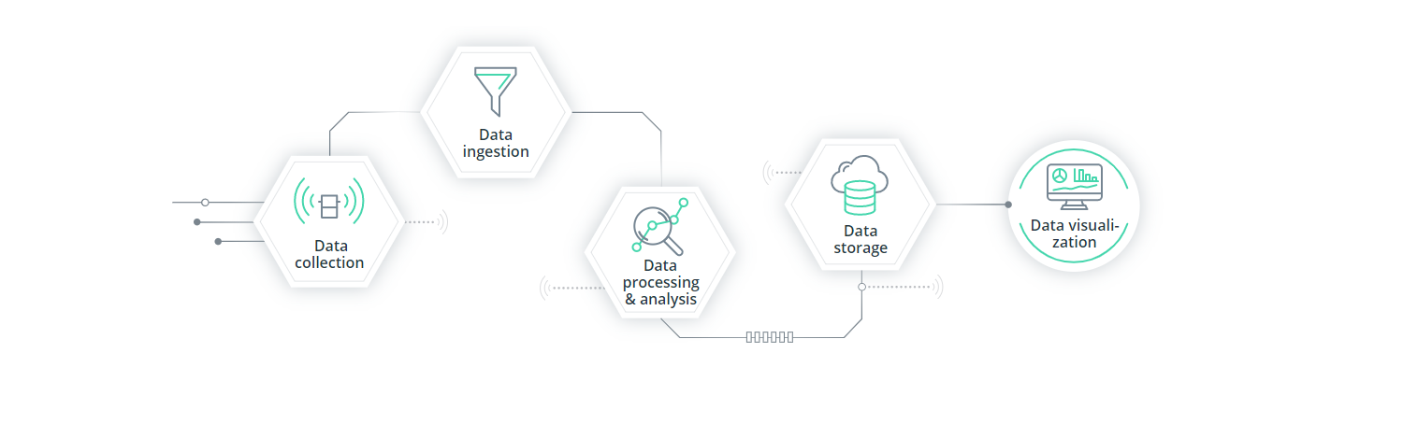

**Vast AI and ML skillset**

We apply mathematical backgrounds and a scientific approach to develop computer algorithms for predicting events and eliminating risks. Our R&D capabilities range from research to creating comprehensive AI and ML models and integrating them into your business solution.

**IoT Center of Excellence**

We help our clients clear project roadblocks fast by bringing together top HumanOne IoT experts in a dedicated Center of Excellence (CoE). Our IoT CoE comprises seasoned professionals who are ready to go beyond their regular activities to resolve your business-critical issues.

**Reasons for choosing HumanOne**

**Top-tier cloud competency**

With our proficiency in cloud computing platforms and services, you can get the highest performing cloud environments. We’ll help you migrate your legacy apps to the cloud or refactor them to meet the challenges of scalability and efficiently manage traffic spikes.

**Cross-industry domain knowledge**

We have a proven record of delivering projects to the world’s leading tech innovators and Fortune 500 companies across many segments. Our experts understand the needs of your industry and will develop custom IoT solutions to drive your business forward.

**Ingenious UI/UX designers**

Our design team is deeply integrated into engineering processes and is closely aligned with our frontend developers to create consistent user experiences for web applications, mobile solutions, human-machine interfaces, and other user-focused products.

**Profound big data expertise**

Intellias big data engineers hold degrees in applied math and computer science and are ready to handle analytical tasks of any complexity. We build reliable software solutions that discover hidden patterns and forecast events to make your data work for you.

**Benefits of UI/UX design you will get**

Get in touch

**Maintain top levels of IoT development security**

Connected devices are a prime target for cybercriminals. Don’t let those threats become a barrier to adoption. Get strategic with your IoT cybersecurity program and learn how to leverage the latest tech innovations to protect your connected assets and transmitted data.

Security stands as our core focus when it comes to IoT product development. Engage with our team to eliminate potential risks and save business time and money. Our specialists will advise on the optimal data encryption approaches and incorporate the latest authentication tech for preventing malicious attacks. With our expert help, you can build and deploy large-scale IoT networks that are bound to withstand any threats.

### **Unlock new business models with custom IoT development**

Today, there are over 200 viable IoT use cases, spanning over multiple industries – automotive, agriculture, retail, e-health and industry 4.0. The big question is – how will your business tap into this newly created value chain? Our IoT development company has some answers.

Incorporate IoT devices into your operations to enable better asset-sharing and sell extra capacities back to the market. Add a pay-per-use or smart subscription offering and capture a wider market by charging your customers for active periods of product use only. As well, you can monetize your IoT data or launch a brand new service line, powered by IoT gadgets. Count on HumanOne team when it comes to Internet of Things software development.

**Eliminate the guesswork from your operations**

Give your hardware a ‘voice’ to unlock deeper insights than any survey or traditional analytics solution can reveal. By combining intelligent devices, data and analytics in one comprehensive IoT platform, you can gain produce new real-time business insights.

Welcome the new era of Internet of Things product development: learn more about your product users or capture equipment performance stats under different conditions. Estimate when your equipment is likely to fail or require maintenance. Understand how drivers are interacting with new connected devices within your vehicle. Learn more about the transporting conditions of your goods and easily locate them within the supply chain.

